**EXTRA QUESTIONS**

Q1: Check whether a string is heterogram or not (Each letter in the string occur only once).

Code:

#include<stdio.h>

#include<string.h>

int main()

{

char s[50];

int i,c=0,flag=0,j;

gets(s);

for (i=0;i<strlen(s);i++)

{

for (j=i+1;j<strlen(s);j++)

{

if (s[i]==s[j])

c++;

}

if (c>=1)

{

flag=1;

break;

}

}

if (flag==0)

printf("Heterogram");

else

printf("Not Heterogram");

return 0;

}

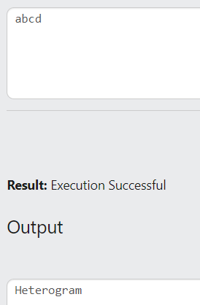

Q2: Remove continuous repeated characters. (Given aaabbbab, it should update as abab).

CODE:

#include<stdio.h>

#include<string.h>

int main()

{

char s1[50],s2[50];

int i,j=0;

gets(s1);

s2[0]=s1[0];

for(i=1;i<strlen(s1);i++)

{

if (s1[i]!=s2[j])

{

j++;

s2[j]=s1[i];

}

}

puts(s2);

}

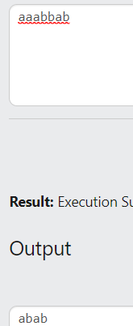

Q3: Given a string S, check whether it’s a Pangram or not. A pangram is a string that contains all alphabets at least once.

CODE:

#include<stdio.h>

#include<string.h>

int main()

{

char s1[50];

int i,j=0,flag=0;

gets(s1);

for (i=97;i<123;i++)

{

flag=0;

for (j=0;j<strlen(s1);j++)

{

if (s1[j]==i)

{

flag=1;

}

}

if (flag==0)

{

flag=2;

printf("Not Pangram");

break;

}

}

if (flag!=2)

printf("Pangram");

}

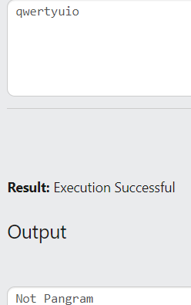

Q4: